**PIZZA SALES PROJECT SQL QUERIES**

***KPIs***

-- Total Revenue

Select SUM(total_price) as Total_Revenue from pizza_sales;

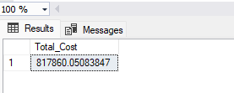

--Avg. Order Value

Select (SUM(total_price)/COUNT(Distinct order_id)) as Avg_order_value FROM pizza_sales;

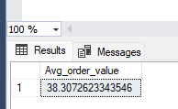

--Total Pizzas Sold

Select SUM(quantity) as Total_Pizzas_Sold from pizza_Sales;

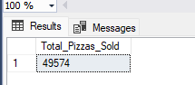

--Avg. Pizzas per order

Select CAST(CAST(sum(quantity) AS decimal (10,2))/

CAST(Count( DISTINCT order_id) AS decimal(10,2)) as decimal(10,2)) as Avg_pizza_per_order from pizza_Sales;

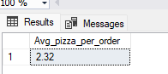

-- Daily Trend for Total Orders

select DATENAME(DW, order_date) as order_day , count(Distinct Order_id) as Total_orders

from pizza_sales

Group by DATENAME(DW, order_date);

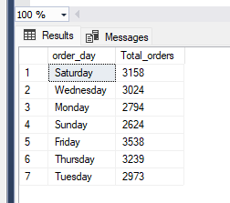

--Monthly trends for Total Orders

Select DATENAME(MONTH, order_date) as Order_Month, count(Distinct order_id) as Total_orders

from pizza_sales

Group by DATENAME(MONTH, order_date);

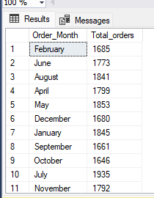

--sales by pizza category

Select pizza_category , sum(total_price) as Total_saales, sum(total_price)*100/(select sum(total_price) from pizza_sales where MONTH(order_date)= 1) as PCT

from pizza_sales

where MONTH(order_date)= 1

Group by pizza_category;

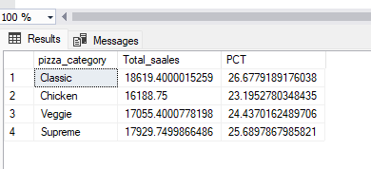

--Percentage of sales by pizza size

Select pizza_size, sum(total_price) as total_sales, CAST(sum(total_price)*100/(select sum(total_price)

from pizza_Sales Where DATEPART(QUARTER, order_date) = 1) as decimal(10,2) ) as PCT from pizza_sales

Where DATEPART(QUARTER, order_date) = 1

Group by pizza_size;

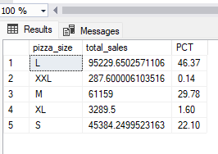

---TOP 5 Best seller by Revenue, Total Quaantity and Total Order

Select TOP 5 pizza_name, sum(total_price) as Total_Revenue, sum(quantity) as Total_quantity

from pizza_Sales

Group by pizza_name

Order by Total_Revenue DESC;

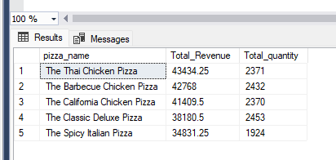

---Bottom 5 Best seller by Revenue, Total Quaantity and Total Order

Select TOP 5 pizza_name, sum(total_price) as Total_Revenue, sum(quantity) as Total_quantity

from pizza_Sales

Group by pizza_name

Order by Total_Revenue;

